Waukesha County 4-H
Kringle Fundraiser
HI 4-H Youth and Families
One of our Fundraisers for 2021 is a Racine Kringle Sale and we need our 4-H youth help! Attached you will find an order sheet that looks like this. Please enter the name(s) of the 4-H youth on the Salesperson line and start taking orders!
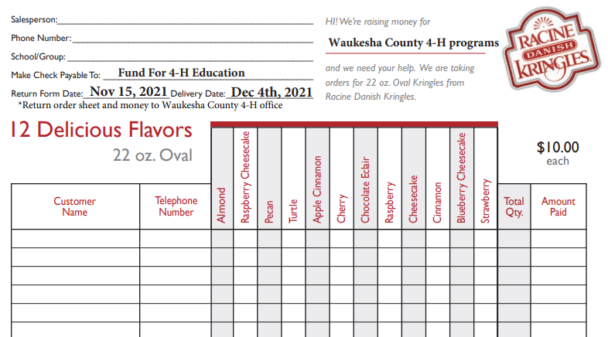

Please send your order forms and money (one check per family is preferred) to the UW Extension office at 515 W Moreland Blvd., Waukesha, WI, 53188 by November 15th.
Kringles can also be ordered online at https://www.waukesha4h.org/
Kringles will be available for pick up on December 4th between 9 am-11 am in the parking lot of the Waukesha County Courthouse (Parking Lot across the street from the building).
4-H families are responsible for picking up their orders.
Questions? Please contact Jann Pfaff at jann.pfaff@waukesha4h.org or Peter Bruce at peter.bruce@waukesha4h.org.

